

## 17 April 2022

REPORT

CA - PROJECT

WEB DESIGN

NCI - Higher diploma in science in computing .

## Mozart Cristiano / Eunice / Lucas

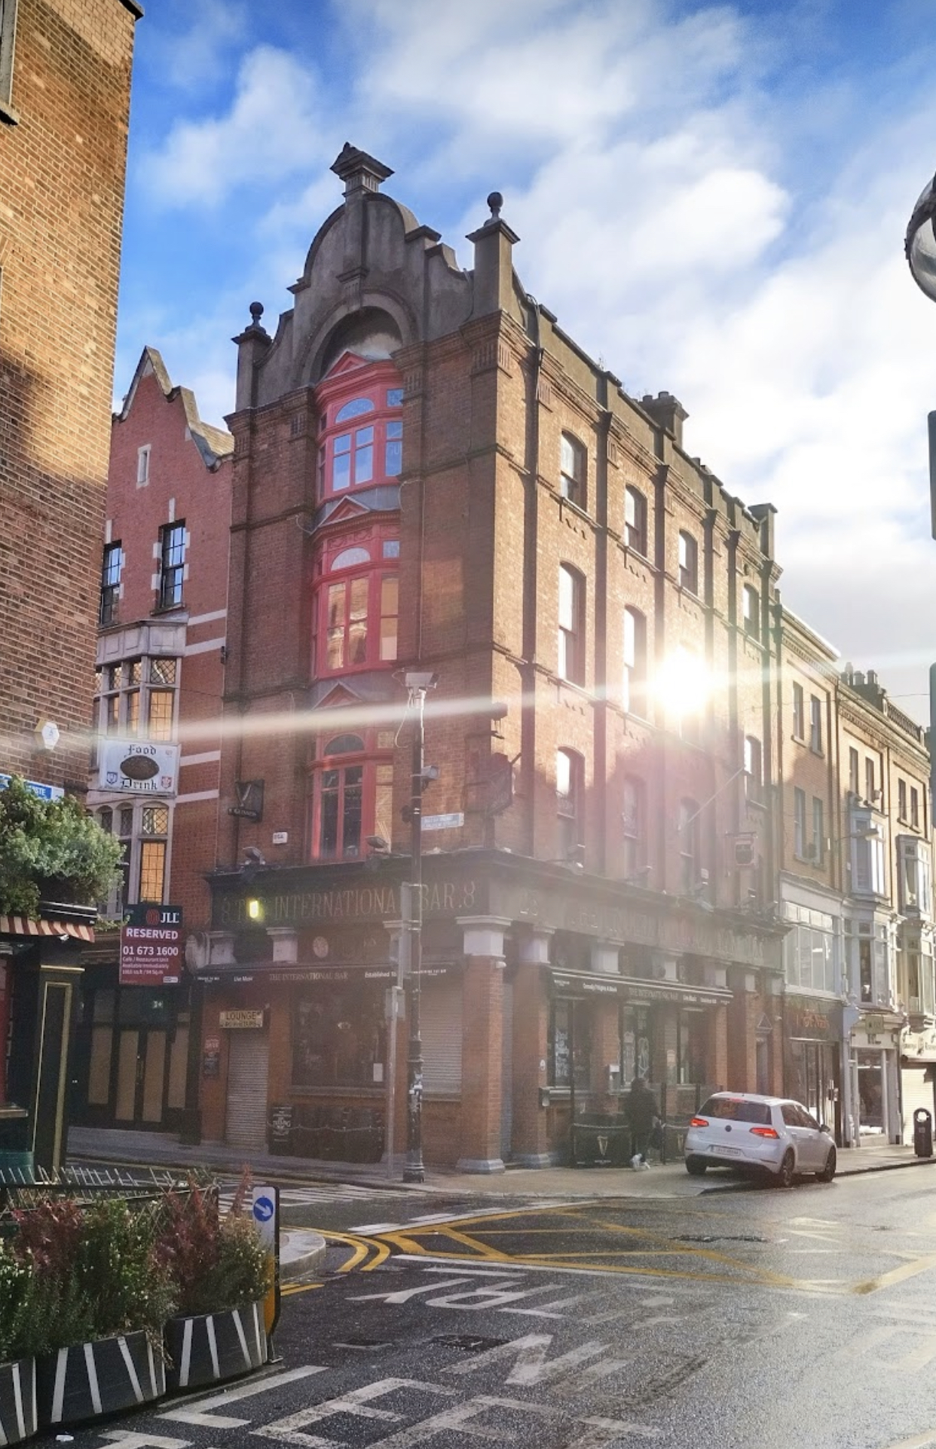The International

Comedy bar

Web development report

**T**

he internet development has brought up a new way in which marketing communication is applied. Therefore, it has been noticed that the most successful Businesses are on the top of the internet commerce.

The hospitality industry in Ireland has grown to an exponential number of just over 7,000 licensed pubs, as a result this figure it is possible to understand the needs for standing out among the competitors. Thus, the growing on the interest of exploring the worldwide

# The client

The owners found important to be on top of the market in order to attract much more visitors to their bar / restaurant.

The reasons of the development of a new website that the owners highlighted are the increase in visibility, fasten the online reservations, promote events of the bar, facilitate the communication between customers and the business providing updates and promotions in a better way and increase credibility showing customer testimonials.

# The Target audience

The most important point when thinking about developing a website is to know the business’ target audience, but to better understand the business’ niche it is necessary to collect data.

According to the insight report, the main consumer groups are people between 25 to 65 years old with no gender restrictions.

When it comes to the target audience’s platform choice the insight report, consumers prefer mobile website rather than desktop, as shown in the graphic below.

# The goals

The reasons of the development of a new website that the owners highlighted are the increase in visibility, fasten the online reservations, promote events of the bar, facilitate the communication between customers and the business providing updates and promotions in a better way and increase credibility showing customer testimonials.

# The design process

We structured the process in five phases. The first phase was comprised of the planning process, which was the most important part. This part required a good understanding of the business and its audience’s need in order to create the appropriate content.

The second phase was comprised of brainstorming ideas, in which we had few meetings where we sketched out some creative ideas for the project.

The third phase was the study of the purpose of the project which was the creation of a high-value content which could generate engagement and Increase the number of customers.

The fourth phase we developed the visual mockups so that we could show to the client how the website would look like, showing all technical tools that would be deployed in the project.

The fifth was the development phase. In this stage we deployed technical assessment and analysing the competitor’s websites in order to see what could be improved in the current business’ website.